Folger MS Y.c.3769

Friedrich I (1754-1816), King of Württemberg 1806-1816 (in Stuttgart).
Dec. 16, 1806. Letter, signed by King Friedrich (=Frederick), from Stuttgart, addressed to Ludwig Schubart (1766-1812).

Transcript:
Seine Königliche Majestät haben das von dem Legatsionsrath Schubart gestern eingereichte Schreiben eingesehen. Da aber bei der so großen Verschiedenheit zwischen den jetzigen Zeiten und den Zeiten Shakespeare's dessen Stücke großer Veränderungen bedürfen, um für das Publicum des gegenwärtigen Zeitalters mit Erfolg benüzt werden zu können, so muß es um so schwerer seyn, unter denselben eine Auswahl zu treffen. Seine Königliche Majestät wollen daher diese ganz dem Autor überlassen. Decr. Stuttgart den 16. Dec. 1806.
Friedrich
Translation:
His Royal Majesty has looked at the letter submitted yesterday by legation counselor Schubart. But since, considering the great difference between present times and the times of Shakespeare, his plays require great changes if they are to be used successfully for an audience of the current era, it must be all the more difficult to make a choice among them. His Royal Majesty will therefore leave that choice entirely to the author. Decreed Stuttgart, Dec. 16, 1806
[signed:] Friedrich

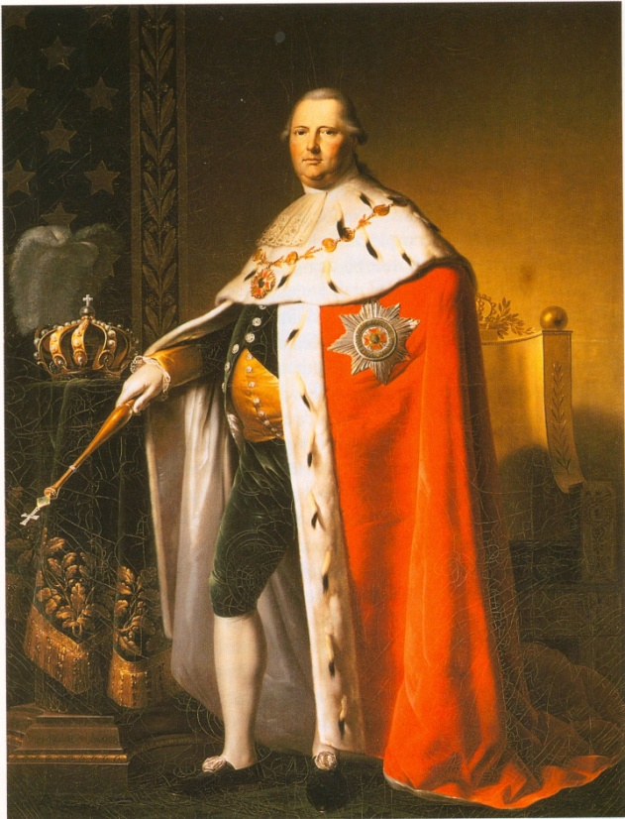
Comments:
Friedrich (1754-1816) had been Duke of Württemberg before he became King Friedrich I of Württemberg in 1806, with his residence in Stuttgart. He was reputed for the late absolutism of his regime. The text is in a secretary's hand; but, judging by other samples of King Friedrich's handwriting, his signature is authentic.

Ludwig Schubart (1766-1812), son of the Poet Christian Friedrich Daniel Schubart (1739-1891), to whose letter the document responds, was indeed a Legationsrat (title in the lower diplomatic service, 'legation counselor'). He was also a writer and a translator of English poetry into German, including James Thomson's The Seasons (Berlin, 1789), Macpherson's 'Ossian' poems (2 vols., Vienna, 1808), and at least four Shakespeare plays: Othello (published Vienna, 1800, and Leipzig, 1802, and later revised), Henry VIII, The Merchant of Venice, and Julius Caesar. The latter three are unpublished, but manuscript copies of all of them are preserved in the Deutsches Literatur Archiv, Marbach. Moreover, they were all (except perhaps for Julius Caesar) performed between 1800 and 1810 at the Stuttgart Court Theatre.
King Friedrich I of Württemberg
Painting by Johann Baptist Seele (c.1806)
High resolution image at
http://commons.wikimedia.org/wiki/Image:Seele-Friedrich_I..jpg
In particular, Henry VIII, in Ludwig Schubart's (prose) translation, was performed, possibly for the first time ever in Germany, on December 14, 1806 – two days before the King issued the present document. A few months earlier, on August 28, 1806, Schubart had sent him a manuscript of that version, with a diplomatically worded covering letter:
Ich nehme mir die Freiheit, Euer königlichen Majestät die kürzlich von mir unternommene Bearbeitung des Shakspearschen Heinrichs VIII zu überreichen, dem ich soviel Interesse zutraue, um die Aufmerksamkeit Euer Majestät zu verdienen, und desen zweckmäßige Darstellung sich vielleicht Ihren Beyfall erwerben dürfte. Schon englische Kunstrichter haben die Bemerkung gemacht, daß sich die Haupthandlung mit Ende des vierten Akts schließe; daß der fünfte eigentlich eine neue Handlung beginne, und nur durch die weitere Ausführung des Königs Interesse gewinne. Dieß sey die einzige Bemerkung, die ich mir hier über das Stück erlaube, das längst unter die vorzüglichsten und caraktervollsten der neueren Bühne gerechnet wird.
[I take the liberty to present to Your Royal Majesty the version undertaken by me of Shakspear's Henry VIII, of which I well believe that it may merit Your Majesty's attention, and the appropriate performance of which might perhaps win Your Majesty's applause. English critics have already observed that the main plot comes to a close at the end of the fourth act; that the fifth act virtually begins with a new plot and is of interest only for its further development of the character of the king. Be this the only remark that I permit myself to make on a play which has long been considered one of the most excellent and characteristic ones of the modern stage.]
When the performance of Henry VIII actually took place on Dec.14, 1806, L. Schubart seems to have felt encouraged immediately to approach King Friedrich again, in a letter the receipt of which "yesterday" (i.e., on Dec.15) is acknowledged in the above royal document of Dec.16. Unfortunately that particular letter of Schubart has not (yet?) been found. One may well guess that he mentioned plans for further Shakespeare translations and his hope for royal consent to their production at the Court Theatre. Supporting letters to King Friedrich also came from theatre director von Waechter. Subsequently Ludwig Schubart did come forward with two more Shakespeare plays, profiting from the King's confidence in his own "choice" and also heeding the King's advice to make Shakespeare palatable for "an audience of the current era". His Merchant of Venice and a thoroughly revised version of his Othello, both performed at the Stuttgart Court Theatre in 1810, are, indeed, heavily adapted – the latter, for instance, by making Othello stab Desdemona instead of strangling her. Thus a brief royal statement as the one preserved on a piece of fading paper and transcribed above can offer some glimpses into ceertain currents of theatre history.
Werner Habicht

For comments see next two pages.
Cf. also Rudolf Krauss, "Ludwig Schubart als Shakespeare-Übersetzer", Shakespeare Jahrbuch 39 (1903), 69-73, where, however, the Julius Caesar translation is declared to be lost ("verschollen"). More recently, Hansjürgen Blinn and Wolf-Gerhard Schmidt in Shakespeare – deutsch: Bibliographie der Übersetzungen und Bearbeitungen (Berlin, 2003) have ignored it altogether. But in fact a manuscript copy is, like of all other Schubart Shakespeare translations, in good shape and well preserved in the Deutsches Literatur Archiv, as the present writer has convinced himself in August 2008.
This letter, too, is in the Deutsches Literatur Archiv (HS002958036).
Quoted in Krauss, op.cit.

